4e Values
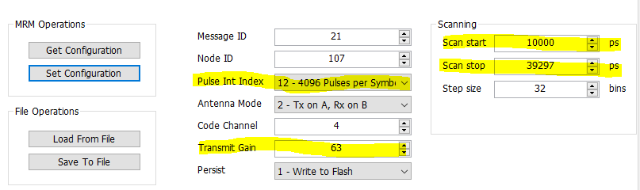
Pulse Int Index: 12
Transmit Gain: 63 dB
Scan start: 10000 ps
Scan stop: 39297 ps

6b Peak Values
Raw: 1,023,620
Bandpass: 959,648
Motion filtered: 1,001,091
Detections: 832,832
First detection as red line: 878,468

7 Peak Values
Raw: 540,052
Bandpass: 596,170
Motion filtered: 518,688
Detections: 540,733
First detection as red line: 595,168

8 Peak Values
Raw: 37,103
Bandpass: 37,144
Motion filtered: 37,079
Detections: 37,342
First detection as red line: 37,129
The signal strength is overall much lower than that of the 12 pulse int index scans.

10 MATLAB Graphs
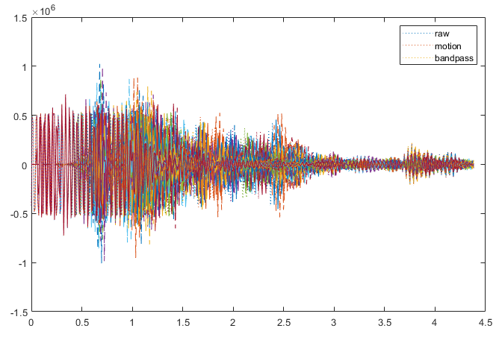
Raw Data from Question 4

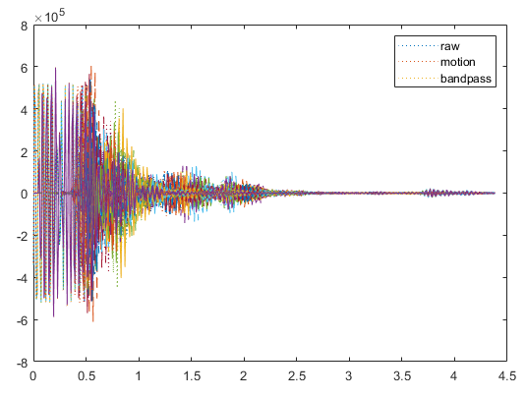
Raw Data from Question 7

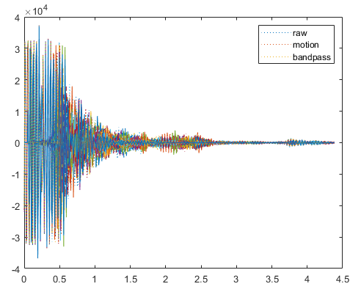
Raw Data from Question 8

Questions and Further Explorations
- For a transmit gain of 63 dB the power at the antenna port is 0.71 W. For a transmit gain of 0 dB the power at the antenna port is -14.48 W.
- Rbin was constructed by converting each scan bin from a time value into a distance using the speed of light and dividing by 2 because the radar signal travels to the target and back. Tbin comes from the radar’s sampling parameters, calculated in ns, which gives the time interval represented by each bin.

